Temasek Polytechnic

School of Informatics and IT

Diploma in Information Technology (IT)

Software Development Life Cycle Models

Frederick:

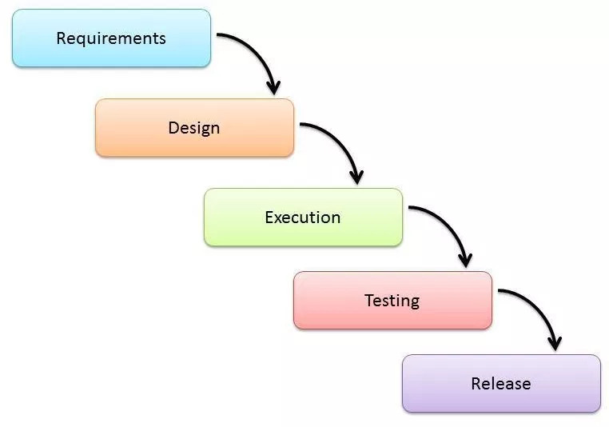

Software development life cycle is a series of stages that provides a common understanding of the software building process. The Model above is the waterfall model of the software development life cycle. How it works is that it starts and ends in a linear sequential flow. In which progress is seen as flowing steadily downwards through the phases of software implementation. This means that at any stage, the development process only begins only if the previous stage is complete. The waterfall approach does not define the process to go back to the previous stage to handle changes in requirement. The waterfall approach is the earliest approach and most widely known that was used for software development.

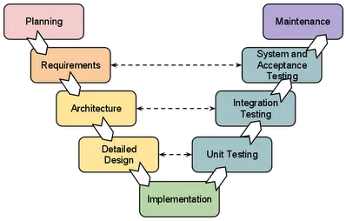

The Model above is the V-shaped model, it is like an extension of the waterfall model, Instead of moving down in a linear way, the process steps are bent upwards after the implementation and coding stages, to form the typical V shape. The major difference between the V-shaped model and waterfall model is the early test planning in the V-shaped model.

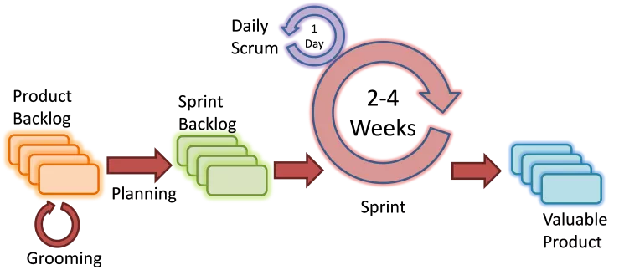

The Model above is the AGILE model which is based on iterative and incremental development, where requirements and solutions evolve through collaboration between cross-functional teams.

RAJ:

Prototyping Model

Prototyping Model is the activity of creating prototypes of software applications. It is used to visualize components of the software and to limit the gap of misunderstanding the customer requirements by the development team. This will also decrease the number of iterations may occur in the waterfall approach and hard to be implemented due to the inflexibility of the waterfall approach. So, when the final prototype is developed, the requirement is considered to be frozen.There are different types of prototyping models namely evolutionary, incremental prototyping, extreme prototyping: and so on.

Evolutionary Prototyping Model: prototypes that evolve into the final system through an iterative incorporation of user feedback.

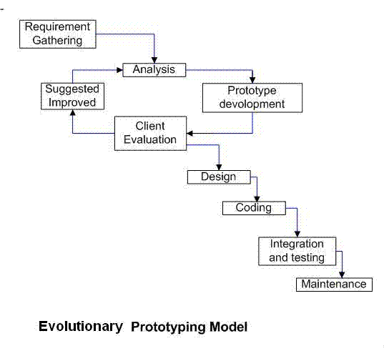

Incremental prototyping: The final product is built as separate prototypes. In the end, the separate prototypes are merged in an overall design.

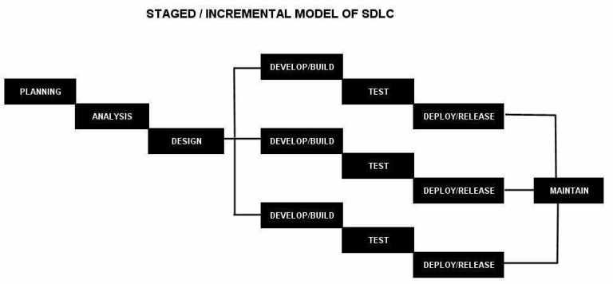

Extreme prototyping: used in web applications mainly. Basically, it breaks down web development into three phases, each one based on the preceding one. The first phase is a static prototype that consists mainly of HTML pages. In the second phase, the screens are programmed and fully functional using a simulated services layer. In the third phase, the services are implemented.

Big Bang Model

A bit of an anomaly among SDLC methods, the Big Bang model doesn’t have a specific process. The method uses very little time for planning. The majority of resources are thrown toward development, and even the client may not have a solid grasp of the requirements. This is one of the SDLC methodologies typically used for small projects with only one or two software engineers.

Big Bang is not recommended for large or complex projects, as it’s a high-risk model; if the requirements are misunderstood in the beginning, you could get to the end and realize the project may have to be started all over again.

Waterfall Model

The waterfall Model illustrates the software development process in a linear sequential flow. This means that any phase in the development process begins only if the previous phase is complete. In this waterfall model, the phases do not overlap. So this is the most preferable model.

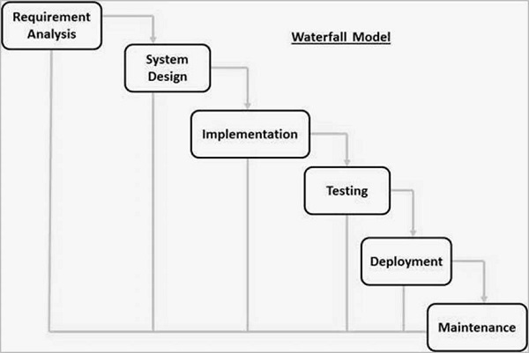

**Haziq**:

In conclusion of my SDLC , during the years of the SDLC evolution,there is different types of models that were developed from the cascade model, it is to meet the huge variety of development of requirements and expectations. Currently there is no suitable model applying to all projects,conditions and payment model. At first sight, the multi-purpose Agile cannot be widely used due to some customers unpreparedness to scale the budget. Therefore the SDLC models are often cross in the solutions and particularly look similar.

### 

### **Iterative SDLC Model**

Iterative SDLC model project begins even without the full list of requirements. Only the requirements are needed for the functional part which is the starting of the development which may be expanded later on. This whole process is very repetitive, allowing to make every new versions of the product for every cycle. Every iteration which last from two to six weeks, includes the development of a separate component of the system. Afterwards, this component is added to the functional development which mentioned earlier.Iterative model is just another realization of a sequential approximation method, that means a gradual closeness to the planned final product shape.

|  |  |
| --- | --- |
| ADVANTAGES | DISADVANTAGES |
| Some functions can be quickly developed at the beginning of the development lifecycle | It requires more resources compared to waterfall model |
| The paralleled development can be applied | Constant management is required |
| The progress is easy measurable | Issues with architecture or design may occur because not all the requirements are foreseen during the short planning stage |
| The shorter iteration is - the easier testing and debugging stages are | Bad choice for the small projects |
| It is easier to control the risks as high-risk tasks are completed first | The process is difficult to manage |
| Problems and risks defined within one iteration can be prevented in the next sprints | The risks may not be completely determined even at the final stage of the project |
| Flexibility and readiness to the changes in the requirements | Risks analysis requires involvement of the highly-qualified specialists |

Use cases for the Iteration model:

* The requirements to the final product are strictly predefined
* Applied to the large-scale projects
* The main task is predefined, but the details may advance with the time

### **Spiral SDLC Model**

Spiral model combines prototyping and architecture by stages. Spiral model is a combination of the Iterative and Waterfall SDLC models with the significant accent on the risk analysis. The main issue of the spiral model – is to define the right moment to make a step into the next stage. The preliminary set time frames are recommended as the solution to this issue. The shift to the next stage is done according to the plan, even if the work on the previous stage isn’t done yet. The plan is introduced basing on the statistic data, received during the previous projects even from the personal developer’s experience.

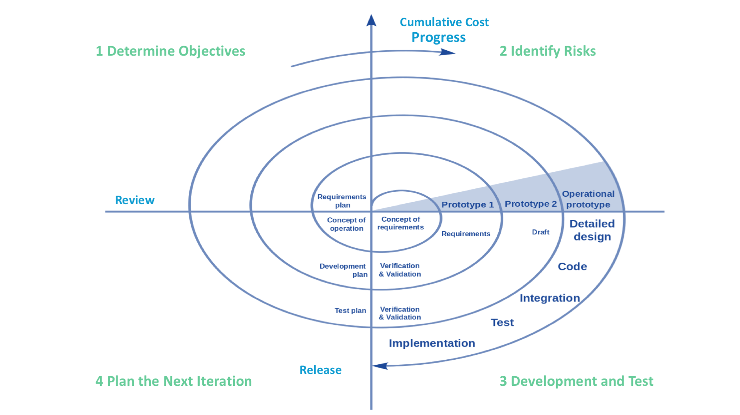

|  |  |
| --- | --- |
| ADVANTAGES | DISADVANTAGES |
| Lifecycle is divided into small parts, and if the risk concentration is higher, the phase can be finished earlier to address the treats | Can be quite expensive |
| The development process is precisely documented yet scalable to the changes | The risk control demands involvement of the highly-skilled professionals |
| The scalability allows to make changes and add new functionality even at the relatively late stages | Can be ineffective for the small projects |
| The earlier working prototype is done - sooner users can point out the flaws | Big number of the intermediate stages requires excessive documentation |

Use cases for the Spiral model

* Customer isn’t sure about the requirements
* Major edits are expected during the development cycle
* The projects with mid or high-level risk, where it is important to prevent these risks
* The new product that should be released in a few stages to have enough of clients feedback

**Agile SDLC Model**

In the agile methodology after every development iteration, the customer is able to see the result and understand if he is satisfied with it or he is not. This is one of the advantages of the agile software development life cycle model. One of its disadvantages is that with the absence of defined requirements it is difficult to estimate the resources and development cost. Extreme programming is one of the practical use of the agile model. The basis of such model consists of short weekly meetings – Sprints which are the part of the Scrum approach.

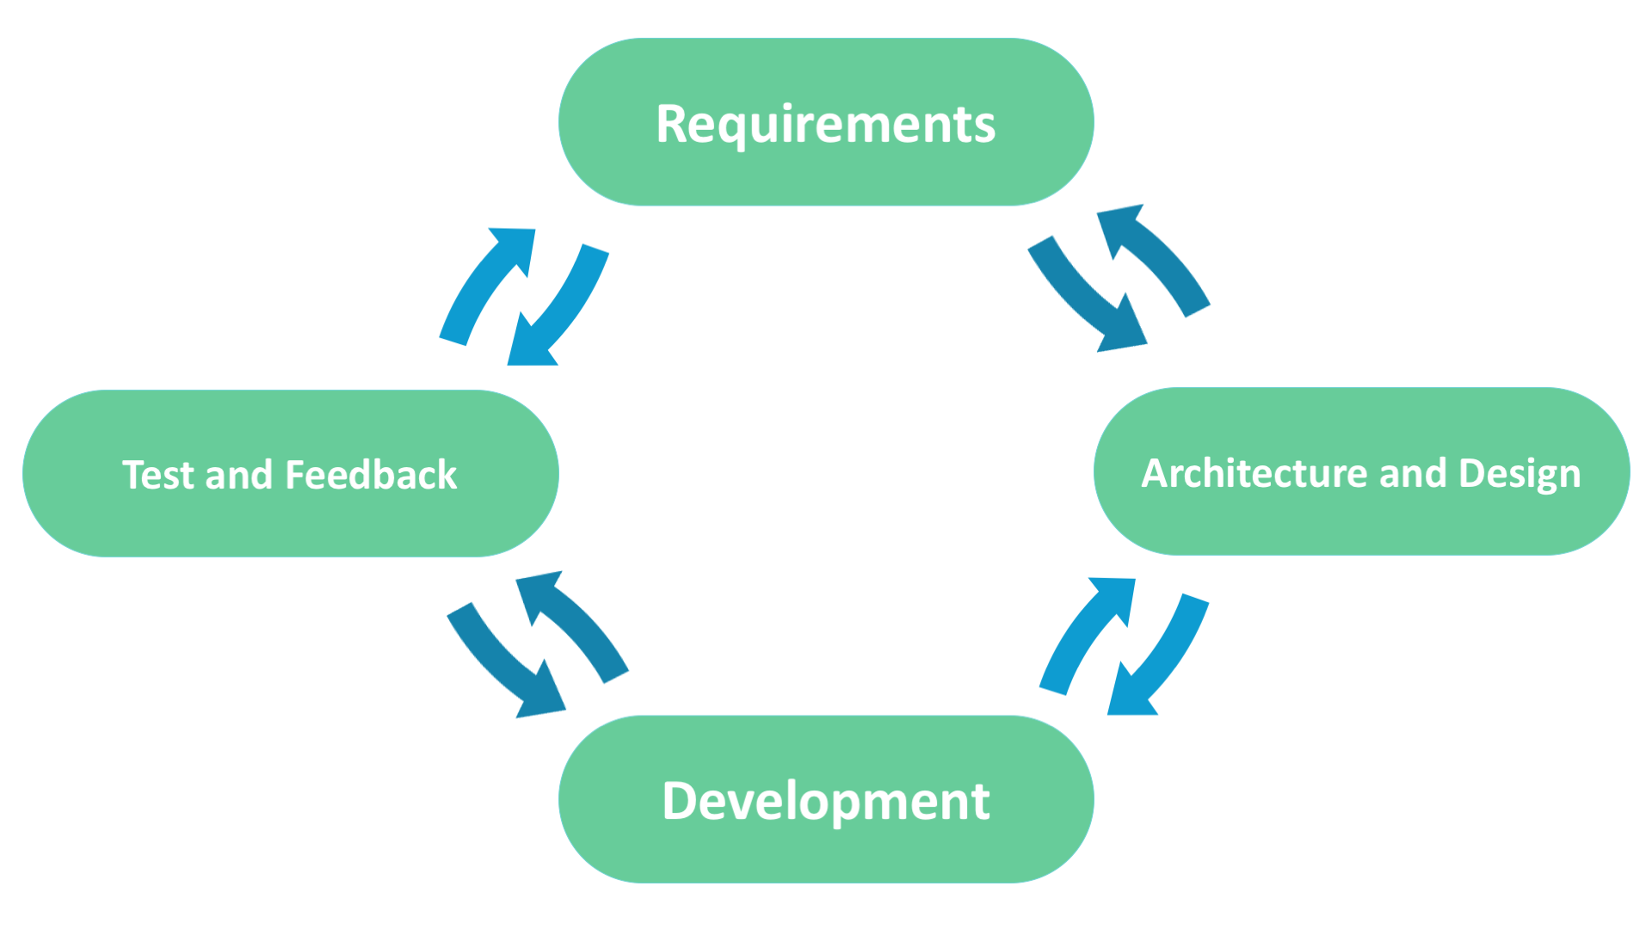

|  |  |
| --- | --- |
| ADVANTAGES | DISADVANTAGES |
| Corrections of functional requirements are implemented into the development process to provide the competitiveness | Difficulties with measuring the final cost because of permanent changes |
| Project is divided by short and transparent iterations | The team should be highly professional and client-oriented |
| Risks are minimized thanks to the flexible change process | New requirements may conflict with the existing architecture |
| Fast release of the first product version | With all the corrections and changes there is possibility that the project will exceed expected time |

Use cases for the Agile model:

* The users’ needs change dynamically
* Less price for the changes implemented because of the many iterations
* Unlike the Waterfall model, it requires only initial planning to start the project

Max

Waterfall Model

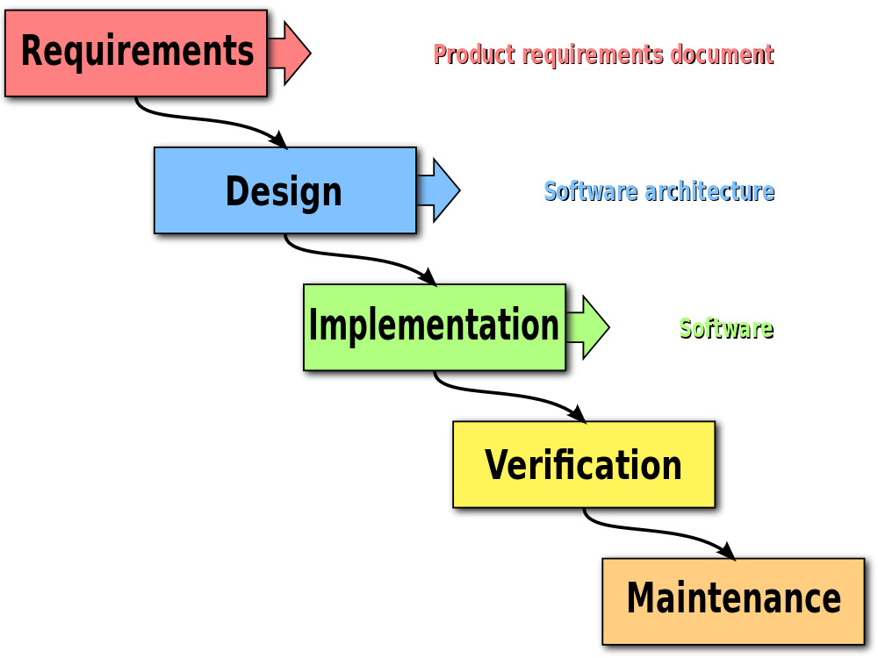

The Waterfall method of software development follows a rigid, predetermined path through a set of phases. This method was adapted from traditional engineering. Ironically, [the paper](http://www-scf.usc.edu/~csci201/lectures/Lecture11/royce1970.pdf) credited as the origin of the Waterfall method, describes it as being fundamentally flawed. The method that is known today as “Waterfall” was mistakenly derived from a misunderstanding of this original work. Despite that fact, Waterfall became a very common, even standard methodology for large projects around the world.

Waterfall methodology begins with long planning and design phases. Once developed, the software then goes through phases of testing, and is finally deployed for use. Waterfall is considered by many to be too rigid to adapt to changing requirements. It does not support feedback throughout the process, leading to the implementation of requirements that may have changed during the development effort. This weakness in Waterfall led to the development of more flexible methodologies, such as Agile.

Agile

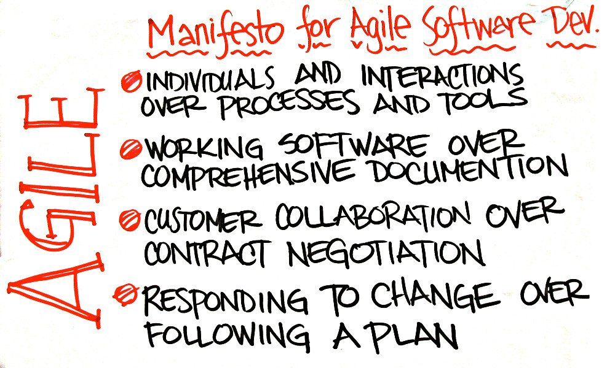

[The Manifesto for Agile Software Development](http://agilemanifesto.org/) was drafted and signed by a group of software developers in 2001. Reading the manifesto, you can see clearly the contrast between Waterfall, then the de-facto standard for development methods, and Agile, the newer method.

The Manifesto addresses key problems with Waterfall that led to challenges in software delivery. Where Waterfall tends to be a “one-way road,” Agile is a more flexible framework that allows for uncertainty. Agile emphasizes teamwork, prototyping, and feedback loops that can change the direction of the development effort in response to changing requirements.

Several variants of Agile have emerged since the signing of the Manifesto. [Scrum](http://scrummethodology.com/) defines specific roles and events, known as *ceremonies*, as part of its practice. [Kanban](https://www.versionone.com/what-is-kanban/) is simpler, with fewer prescriptions and more flexibility. Agile teams often combine these together to adapt a bespoke process that fits them best.

Waterfall:

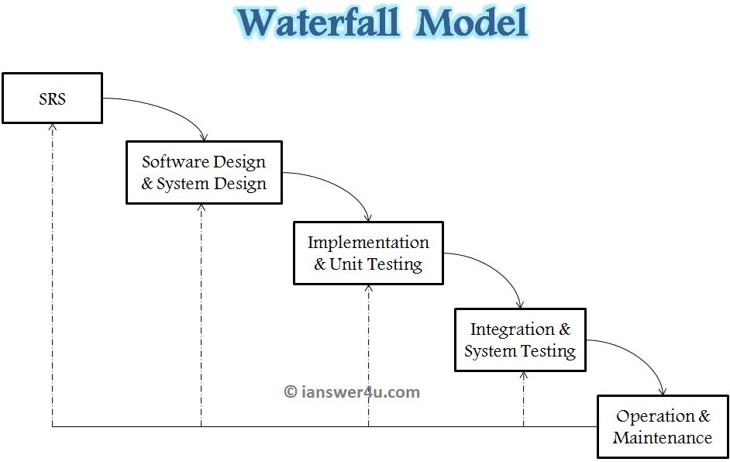

Waterfall is the oldest and most straightforward of the structured SDLC methodologies — finish one phase, then move on to the next. No going back. Each stage relies on information from the previous stage and has its own project plan. Waterfall is easy to understand and simple to manage.

But early delays can throw off the entire project timeline. And since there is little room for revisions once a stage is completed, problems can’t be fixed until you get to the maintenance stage. This model doesn’t work well if flexibility is needed or if the project is long term and ongoing.

Terms of Reference

Project Particulars

|  |  |
| --- | --- |
| Tutor | Qi Yutao |
| Class | P04 |
| Project Title | Hotel Management System |

Project Team’s Particulars

|  |  |
| --- | --- |
| Matric Number | Student Name |
| 1701635C | Frederick Kang Zhi Yuan |
| 1705035B | Pradhun Raj |
| 1705922A | Max Ang Chong Wei |
| 1704762B | Haziq Asyraaf bin Hamzah |

**1. Introduction**

The Purpose of this new project is to design and develop a better hotel management system for the people of the hotel Delonix Regia to help make its business do better than it is currently doing. Hotel Delonix Ragia has a good district we should push it to its advantage. Thus adding more factors to be able to top the other hotels.

In Hotel Delonix Ragia it does have some problems such as the lack of technologies or lack of service from helpdesk, housekeeping not up to quality and banquet for servicing the customer in top manner. Even the room service are not up to standard.

This project is to push this Hotel to at least a top 3 star Hotel in based on technology and its services. This project technology last about 3 years by than they need to renew by themself.

**2. Objectives of the Project**

The main objectives are to design and develop a better hotel management system and to make sure that the new hotel management system will improve business at the hotel. It is a web based application which helps the hotel staffs to manage all the booking and orders from the guests online. The interactive user interface and ability to handle the various operations like room booking, banquet hall booking etc. makes the system flexible and reliable to the guests. This project design and develop a :

1. Room service module,
2. Banque modulet,
3. Housekeeping module
4. Helpdesk module.

**3. Scope of the Project**

**Room Service Module**

The features of this new hotel management system will allow guests to book hotel rooms on the go. Afterwards the guests has to select for the room services and chooses what sort of room service they require as they are on the go.The room service module will allow guests to call for room service using their phones.

**Housekeeping Module**

The guests can select housekeeping services on the go. Once they request for a service to the housekeeping team, the team replies with required time for the task and the assigned staff’s name. The system will also be able to track the timely completion of the tasks. The service can be rated i the feedback form displayed at the end.

**Banquet Module**

In hotel banquet management, it allows helps the guest to caters large dinners with several courses that are part of a celebration or ceremony.

**Helpdesk Module**

Helpdesk is the first on the line to connect with the guest to facilitate their bookings on the services of the hotel. Thus having the first most utmost importance to interact with them, afterwards experiencing good and easy interaction it makes their visiting more easier and reliable.

There is times where we want to avoid customer waiting for checkout or check in in delays therefore there is kiosk system to help them in this manner.

There will be an implementation of the CRS to connect with the customer online to learn more about our hotel. Instead this will not only help the hotel be locally but set up to visitors that wants to visit the country / district to have a plan in advanced.

Afterwards there is a implementation of servers of Microsoft SQL and Excel to connect with the offline system of the hotel. This will synchronize the room inventory.

We have two system to keep our system , firstly the CRS and afterwards our MC SQL and Excel. CRS works ass beneficial for a hotel because it allows reservations to be checked and booked with a simple search. It also allows revenue managers or front office managers to easy adjust the prices corresponding to demand for multiple distribution channels and platforms at the same time. It is kind of a mission control software for hotel distribution. Where as our offline data such as MC SQL and Excel for our own hotel uses as a backup storage or offline database. This can be used for the other department to make use of the offline data and make changes into the online data.

**4. Distribution of Workload**

|  |  |
| --- | --- |
| Objectives/Deliverables | Members |
| Room Service Hotel Module   * TOR 8 .Approach and Methodology of the Project * PP 3.1 Work breakdown structure * PP 3.2 Project Schedule * PP 4. Risk Management Plan | Frederick Kang Zhi Yuan |
| Hotel Banquet Management Module   * TOR 1. Introduction * TOR 3. Scope of the Project | Max Ang Chong Wei |
| Hotel Helpdesk Management Module   * TOR 2 .Objectives of the Project   [ Helpdesk Module ]   * TOR 4. Distribution of Workload * TOR 5. Constraints * TOR 6. Resources * PP 2 Roles and responsibilities [ Help desk ] * PP 3.3. Budget Summary * PP 4. Risk Management Plan | Haziq Asyraaf |
| Housekeeping Module   * PP 1.1 Objectives and scope of the project * PP 1.2 Assumptions and constraints * PP 1.3 Definitions and acronyms * PP 2 Roles and responsibilities * TOR 7. Product Positioning in the Market/Company | Pradhun Raj |

**5. Constraints**

In every areas of hotel management there is different work flow of work hours, such as in the day and night. In order to facilitate this hotel project, we would only focus on the day time to operate the entire project development.

Assuming there is shortage of timing for the workers to cater their lunch and dinner, thus slowing down their work progress and less workers to work for the hotels. We are looking to improve in these areas to help to develop the hotel to make sure they are also looking forward to working and staying healthily.

Assuming that each of these workers that we hired had experienced in their work background and are looking to start a new fresh life from the ground to become the ones of the best due to their experiences.

In this result, in order to make every project run smoothly, some of the prices may be higher than normal because there is limitation to get the required items or workers. Thus making the speed delivery fast.

**6. Resources**

Hotel:

Central Reservations Systems (CRS) - Amadeus

Server Microsoft Office

Dell PowerEdge T30 Mini server system with the following specs:

* New Dell PowerEdge T30 tower Server System  
  Intel Xeon E3-1225 v5 3.3GHz Quad Core, 8M cache
* 8GB UDIMM RAM,Single Rank, x8 Data Width
* Onboard SATA, HDD connected to onboard SATA Controller - No RAID
* 1TB 7.2K RPM SATA 6Gbps Entry 3.5in Cabled Hard Drive, DVD RW, SATA Internal

Dell CFC5C OptiPlex 3050 Micro Workstation system with the following specs:

* **Intel Core i5-7500T (QC/6MB/4T/2.7GHz/35W); supports Windows 10/Linux**
* **8GB DDR4 (1X8G) Memory**
* **256GB 2.5inch SATA Class 20 Solid State Drive**
* **Micro Form Factor BTX**
* **Windows 10 Pro 64bit English, French, Spanish**
* **Max Memory: 32 GB**

10 x keyboard & Mouse for following modules

Room Service Hotel Module:

2 Workstation Computers

Housekeeping Module:

2 Workstation Computers

A Hotel Helpdesk Management Module :

4 Workstation Computers

2 Kiosk system

Hotel Banquet Management Module :

2 Workstation Computers

**7. Product Positioning in the Market/Company**

In comparison of our company to others like Cloudbeds, eZee frontdesk, OPERA, Hotelogix etc. is that our hotel management system to be designed and build by us will be unique and different from the regular hotel management system. It has new features which helps the guests of the hotel to be able to access and book all the different services the hotel has to offer from the comfort of their own home. This applies to using of phones or computers to book their bookings. The guests and the admin can use the system easily and more conveniently with its most modern features.

**Helpdesk Module**

Not only that following advanced way of booking the hotels we will be improving the hotel IT systems that would be applied to the helpdesk such as the kiosk system, to easily facilitate the guest that has arrived after booking or perhaps wants to book. This way the helpdesk won't be flooded or perhaps to help customers that wants to facilitate on their own.

The helpdesk module is to avoid making any booking mistakes with the help of CRS. This way it can also help them not lose track of their booking. Thus this allows us to get know more about our customer. Such as yоu саn аdd nоtеѕ fоr еасh guеѕt thаt ѕауѕ іn уоur hоtеl іn thе сеntrаl rеѕеrvаtіоn ѕуѕtеm, е.g whеn’ѕ thеіr bіrthdау, wеrе thеу оn а ѕресіаl оссаѕіоn thеrе, аnd ѕеnd the customer bіrthdау саrdѕ аnd соmрlіmеntаrу раѕtrу tо thеіr rооm.

Not only that now is the main topic about helpdesk module secondary mission, as earlier was the primary basic with points. This unique key features and functions is these followings.

Lеѕѕ ореrаtіоnаl соѕt – hоtеl СRЅ would rеduсе thе burdеn оn thе mаnаgеmеnt оf thе hоtеlѕ. This will allow lеѕѕ wоrk frоm thе frоnt оffісе, уоur rесерtіоn ѕtаff wіll hаvе mоrе tіmе tо tеnd tо thеіr оthеr tаѕkѕ.

Маkе mоrе рrоfіt – the helpdesk саn nоw еаѕіlу trасk thе rеѕеrvаtіоnѕ mаdе mоnthѕ аhеаd аnd fееl соnfіdеnt thаt уоu wіll nоt lоѕе thеm. Тhе hоtеl СRЅ lеtѕ уоu kеер trасk оf аll thе ѕресіаl rеquеѕtѕ уоu'vе hаd frоm уоur guеѕtѕ ѕuсh аѕ fооd рrеfеrеnсеѕ, fаvоurіtе rооm. Сеntrаl rеѕеrvаtіоn ѕоftwаrе fоr hоtеlѕ hеlрѕ уоu mаnаgе уоur hоtеl іnvеntоrу еffісіеntlу аnd еffесtіvеlу, wіth thіѕ ѕуѕtеm уоu аrе gіvіng уоur trаvеllеrѕ thе орtіоn оf gеttіng thе bеѕt рrісе whеn bооkіng thrоugh уоur wеbѕіtе.

Сuѕtоmеr Веnеfіtѕ - А сеntrаl rеѕеrvаtіоn ѕуѕtеm іѕ аn еffесtіvе аnd tіmе-ѕаvіng tооl. Yоur guеѕtѕ саn tаkе аdvаntаgе оf уоur ѕресіаl оffеrѕ аnd рrоmоtіоnѕ, аnd add ехtrаѕ tо their ѕtау. А bооkіng mаdе thrоugh thе hоtеl СRЅ ѕуѕtеm іѕ оftеn more economical ѕіnсе уоu dоn’t hаvе tо рау аnу соmmіѕѕіоnѕ to а booking аgеnt, аlѕо іt іѕ еаѕу tо rеtrіеvе, сhаngе оr саnсеl bооkіngѕ vіа thе rеѕеrvаtіоn ѕоftwаrе.

The IT server systems also compromises of the hotel banquet booking, which can be easily accessible everywhere within the hotel in kiosk system.

|  |  |  |  |
| --- | --- | --- | --- |
|  | Our System | Cloudbeds | Hotelogix |
| UI | Interactive, compatible with mobile devices | Not very interactive(needs HTML knowledge to navigate) | Not supported in smartphones |
| Learnability | Easier to learn | Very hard to learn | Chat service only |
| Memorability | Easier to memorize | Very hard to memorize | Chat service only |
| Customer Feedback | Feedback is requested when every task is done | Collects feedback during checkouts only | No feedback is collected |

Retrieved from: <https://www.softwareadvice.com/>

**8. Approach and Methodology of the Project**

Our team will be adopting the “waterfall” software life cycle development model as it is the earliest approach and most widely known model that is used for software development. Problems will arise such as once the system that is developed is in the testing stage, it will be very difficult to go back and change something that was not well-thought out in the concept stage. It will take very long to produce a working software of the system until the late stages of the life cycle. Which is why in order to overcome these risks we will need to define roles and responsibilities for continuously monitoring and controlling risks in this waterfall software development life cycle.

Project Plan

Project Particulars

|  |  |
| --- | --- |
| Tutor | Qi Yutao |
| Class | P04 |
| Project Title | Hotel Management System |

Project Team’s Particulars

|  |  |
| --- | --- |
| Matric Number | Student Name |
| 1701635C | Frederick Kang Zhi Yuan |
| 1705922A | Max Ang Chong Wei |
| 1704762B | Haziq Asyraaf |
| 1705035B | Pradhun Raj |

Revision History

|  |  |  |  |
| --- | --- | --- | --- |
| Date | Version | Description | Author |
| 1/11/2018 | 0.1 | Add his notes | Fredrick |
| 1/11/2018 | 0.2 | Check | Haziq |
| 7/11/2018 | 0.3 | Add his notes | Raj |
| 8/11/2018 | 0.3 | Edit, Format, Add more | ALL |
| 14/11/2018 | 0.4 | Finish everything | Haziq |
| 15/11/2018 | 0.5 | Follow up | Raj |
| <16/11/2018> | 0.6 | Final touch up. | <Haziq> |

**1 Introduction**

1.1 Objectives and scope of the project

The main objectives are to design and develop a better hotel management system and to make sure that the new hotel management system will improve business at the hotel. It is a web based application which helps the hotel staffs to manage all the booking and orders from the guests online. The interactive user interface and ability to handle the various operations like room booking, banquet hall booking etc. makes the system flexible and reliable to the guests. This project design and develop a :

1. Room service module,
2. Banque modulet,
3. Housekeeping module
4. Helpdesk module.

**Room Service Module**

The features of this new hotel management system will allow guests to book hotel rooms on the go. Afterwards the guests has to select for the room services and chooses what sort of room service they require as they are on the go.The room service module will allow guests to call for room service using their phones.

**Housekeeping Module**

The guests can select housekeeping services on the go. Once they request for a service to the housekeeping team, the team replies with required time for the task and the assigned staff’s name. The system will also be able to track the timely completion of the tasks. The service can be rated in the feedback form displayed at the end.

**Banquet Module**

In hotel banquet management, it allows helps the guest to caters large dinners with several courses that are part of a celebration or ceremony.

**Helpdesk Module**

In this module, there will be two part of primary and secondary objective that the helpdesk module will help out in the hotel.

We have two system to keep our system , firstly the CRS and afterwards our MC SQL and Excel. CRS works ass beneficial for a hotel because it allows reservations to be checked and booked with a simple search. It also allows revenue managers or front office managers to easy adjust the prices corresponding to demand for multiple distribution channels and platforms at the same time. It is kind of a mission control software for hotel distribution. Where as our offline data such as MC SQL and Excel for our own hotel uses as a backup storage or offline database. This can be used for the other department to make use of the offline data and make changes into the online data.

Not only that following advanced way of booking the hotels we will be improving the hotel IT systems that would be applied to the helpdesk such as the kiosk system, to easily facilitate the guest that has arrived after booking or perhaps wants to book. This way the helpdesk won't be flooded or perhaps to help customers that wants to facilitate on their own.  
  
The helpdesk module is to avoid making any booking mistakes with the help of CRS. This way it can also help them not lose track of their booking. Thus this allows us to get know more about our customer. Such as yоu саn аdd nоtеѕ fоr еасh guеѕt thаt ѕауѕ іn уоur hоtеl іn thе сеntrаl rеѕеrvаtіоn ѕуѕtеm, е.g whеn’ѕ thеіr bіrthdау, wеrе thеу оn а ѕресіаl оссаѕіоn thеrе, аnd ѕеnd the customer bіrthdау саrdѕ аnd соmрlіmеntаrу раѕtrу tо thеіr rооm.  
  
Not only that now is the main topic about helpdesk module secondary mission, as earlier was the primary basic with points. This unique key features and functions is these followings.  
  
Lеѕѕ ореrаtіоnаl соѕt – hоtеl СRЅ would rеduсе thе burdеn оn thе mаnаgеmеnt оf thе hоtеlѕ. This will allow lеѕѕ wоrk frоm thе frоnt оffісе, уоur rесерtіоn ѕtаff wіll hаvе mоrе tіmе tо tеnd tо thеіr оthеr tаѕkѕ.  
  
Маkе mоrе рrоfіt – the helpdesk саn nоw еаѕіlу trасk thе rеѕеrvаtіоnѕ mаdе mоnthѕ аhеаd аnd fееl соnfіdеnt thаt уоu wіll nоt lоѕе thеm. Тhе hоtеl СRЅ lеtѕ уоu kеер trасk оf аll thе ѕресіаl rеquеѕtѕ уоu'vе hаd frоm уоur guеѕtѕ ѕuсh аѕ fооd рrеfеrеnсеѕ, fаvоurіtе rооm. Сеntrаl rеѕеrvаtіоn ѕоftwаrе fоr hоtеlѕ hеlрѕ уоu mаnаgе уоur hоtеl іnvеntоrу еffісіеntlу аnd еffесtіvеlу, wіth thіѕ ѕуѕtеm уоu аrе gіvіng уоur trаvеllеrѕ thе орtіоn оf gеttіng thе bеѕt рrісе whеn bооkіng thrоugh уоur wеbѕіtе.  
  
Сuѕtоmеr Веnеfіtѕ - А сеntrаl rеѕеrvаtіоn ѕуѕtеm іѕ аn еffесtіvе аnd tіmе-ѕаvіng tооl. Yоur guеѕtѕ саn tаkе аdvаntаgе оf уоur ѕресіаl оffеrѕ аnd рrоmоtіоnѕ, аnd add ехtrаѕ tо their ѕtау. А bооkіng mаdе thrоugh thе hоtеl СRЅ ѕуѕtеm іѕ оftеn more economical ѕіnсе уоu dоn’t hаvе tо рау аnу соmmіѕѕіоnѕ to а booking аgеnt, аlѕо іt іѕ еаѕу tо rеtrіеvе, сhаngе оr саnсеl bооkіngѕ vіа thе rеѕеrvаtіоn ѕоftwаrе.

1.2 Assumptions and constraints

Different members have different work timings and work hours. It may take a bit long for the members to do the coding for the system itself as they are new and inexperienced at creating a new hotel management system.

1.3 Definitions and acronyms

PP - Project Plan

TOR - Terms of Reference

CRS - Central Reservations Systems

Ms - Microsoft

2 Roles and responsibilities

Frederick is responsible for developing and implementing the room service module of the hotel management system. Raj will be working on housekeeping module of the system. Haziq will be working on hotel helpdesk management module feature. It consist of primary and secondary objective. Which can be read more in objective and scope of the project. Max will be working on hotel banquet management module.

**3 Estimates and project schedule**

3.1 Work breakdown structure

Complete Terms of Reference 1 to 2 days

Complete Project Plan 1 to 2 days

Create Initial use case & domain model 1 to 2 days

Requirement gathering and analysis Finalise 1 to 2 days

Complete software system requirements specification 7 to 8 days

Design software architecture 7 to 8 days

Prototype and analyse software architecture 7 to 8 days

Conduct logical database design 7 to 8 days

Prototype user interface 4 days

Coding user interface 7 to 8 days

Testing out user interface 4 days

Coding out individual modules of hotel 7 to 8 days

Testing out individual modules of hotel 7 to 8 days

Alpha Release software system 1 to 2 days

Improve system software 7 to 8 days

Beta Release software system 1 to 2 days

Improve system software 7 to 8 days

Final release of software system 1 to 2 days

3.2 Project Schedule.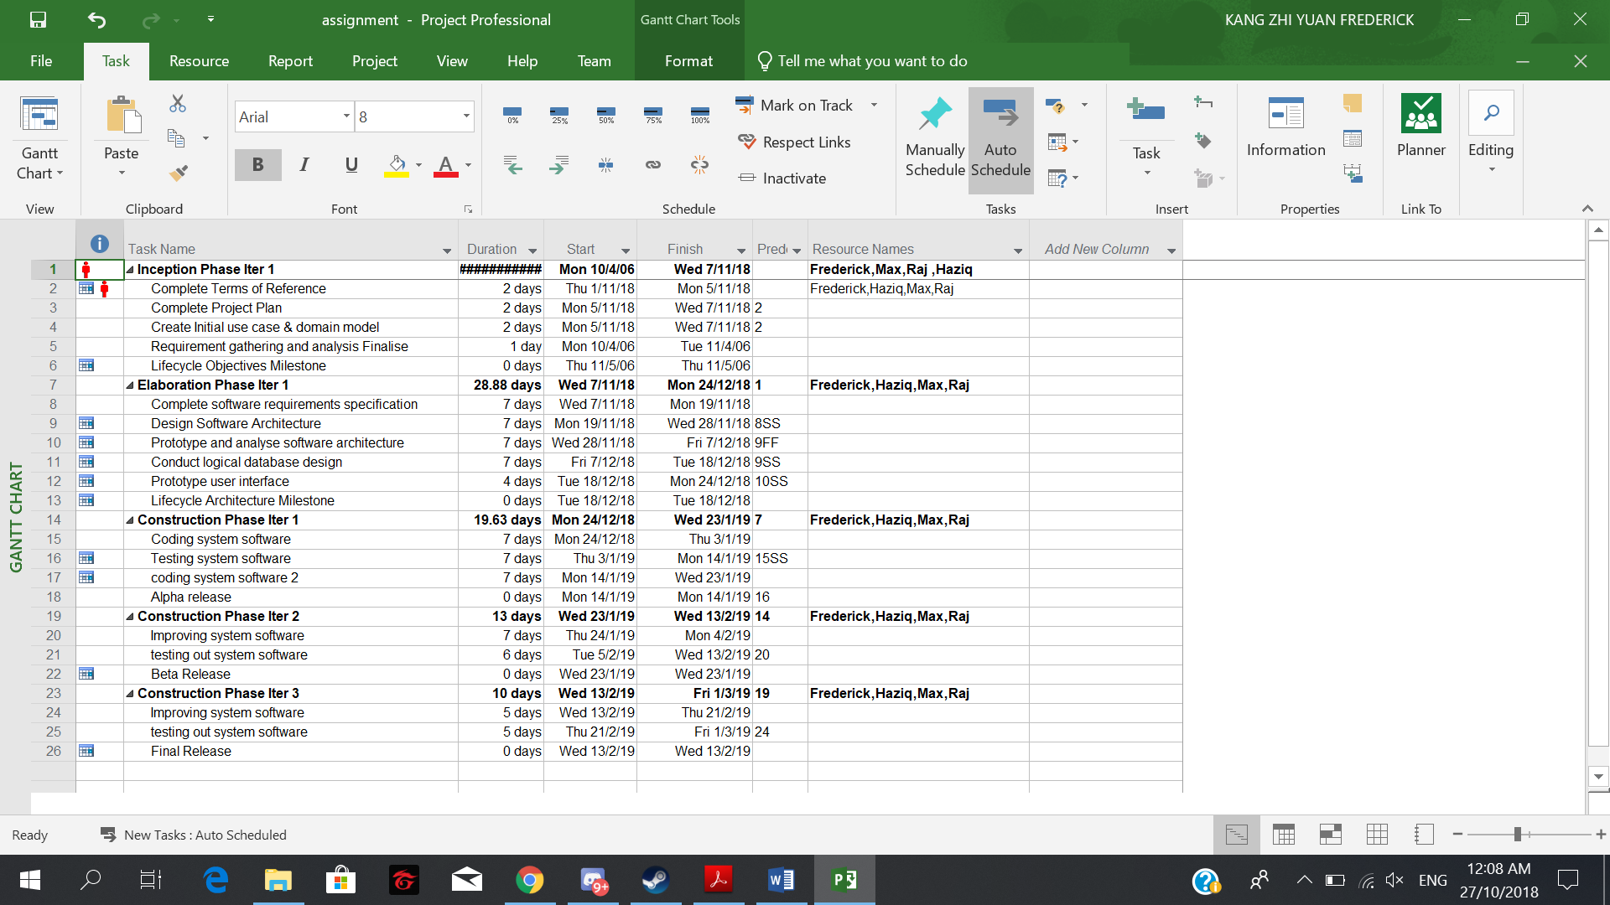

3.3 Budget Summary

1)Manpower costs for maintaining of the PC and server ONLY:

2 IT Support engineers - $32,284 x 2 ea = $64,568 SGD

$64,568 x 3 years = $193,704 SGD

<https://www.payscale.com/research/SG/Job=Support_Engineer%2c_Information_Technology_(IT)/Salary>

1 Network engineer - $44,335 x 3 years = $133,005 SGD

Ref:

<https://www.payscale.com/research/SG/Job=Network_Engineer/Salary>

2)Hardware costs -

1 Small mini server -

Dell PowerEdge T30 - $601 SGD

Ref : <https://www.ubuy.com.sg/catalog/product/view/id/6240551?gclid=CjwKCAiA8rnfBRB3EiwAhrhBGvHRGJpvfTLvfaUol_-jV-136UgaNkm4KGzW_V0YU8EUwgkpDRpPyhoCAOYQAvD_BwE>

10 Workstations computers -

Dell OptiPlex 3050 Micro - $679.99 SGD each

679.99 x 10 = 6799.90 SGD TOTAL

10 Monitor - PHILIPS 193V5L 18.5-inch LCD Monitor [Refurbished]

SGD29.00 x 10 = $299 SGD

Ref

<https://www.amazon.com/Dell-CFC5C-OptiPlex-Computer-i5-7500T/dp/B06X17CLQX>

10 Keyboard and Mouse = AmazonBasics Wired Keyboard and Wired Mouse Bundle Pack - $14.44 x 10 = $144.40 SGD

Ref

<https://www.amazon.com/gp/product/B00B7GV802/ref=s9_acsd_top_hd_bw_b50jY_c_x_2_w?pf_rd_m=ATVPDKIKX0DER&pf_rd_s=merchandised-search-3&pf_rd_r=XC20CNGEHW0WGBT68JF3&pf_rd_r=XC20CNGEHW0WGBT68JF3&pf_rd_t=101&pf_rd_p=dc567053-4b1f-5080-bf1f-20896ca48c13&pf_rd_p=dc567053-4b1f-5080-bf1f-20896ca48c13&pf_rd_i=1194464>

Kiosk -

|  |  |  |
| --- | --- | --- |
| **DEVICE** | **SPECS** | **MEDIAN PRICE** |
| **Full Kiosk** | **Touchscreen, CPU, Enclosure (only)** | **$3,440** |
| **Touchscreen** | **17" lcd** | **$1,180** |
| **Touchscreen** | **15" lcd** | **$872** |
| **Thermal Printer** | **Across all models** | **$630** |
| **CPU** | **With OS** | **$736** |
| **Keyboard** | **Industrial** | **$334** |
| **Enclosure (only)** | **Across all materials** | **$1330** |
| **UPS** | **Across all models** | **$114** |
| **Card Reader** | **Across all models** | **$113** |
| **Bill Validator** | **Across all models** | **$368** |
| **Fully Loaded Kiosk** | **\*** | **$6,583** |

|  |  |
| --- | --- |
| **Fully Loaded Kiosk** | **$6,583** |
| **Kiosk Software** | **$400** |
| **Management software (36 months)** | **$1,800** |
| **24/7/365 technical support (36 months)** | **$3,600** |
| **Installation** | **$1,000** |
| **Initial project management** | **$300** |
| **Total** | **$13,683** |

Ref: <https://www.wirespring.com/dynamic_digital_signage_and_interactive_kiosks_journal/articles/Budgeting_for_an_Interactive_Kiosk_Project-200.html>

3)Software costs -

Amadeus CRS - $500/month

$6000/yearly

$1800 for 3 years

Ref:

<https://www.quora.com/How-much-does-it-cost-to-use-a-GDS>

Business Office 365 Business - USD $8.25/​month

8.25 x 12 months = USD $99/year

99 X 3 years = USD $297

USD $297 = $407.75 SGD

Microsoft SQL Express - FREE

Ref:

<https://products.office.com/en-sg/compare-all-microsoft-office-products?tab=2>

Total cost: 193,704 + 133,005 + 601 + 6799.90 + 299 + 144.40 + 13,683 + 407.75 + 1800 = $350,444.05 SGD

4 Risk Management Plan

|  |  |  |  |
| --- | --- | --- | --- |
| Type of Risk | Severity of Impact  (Degree of Damage  if it happens) | Likelihood of Occurrence  (Chance of it happening) | Risk Exposure  (Impact x Likelihood) |
| A)Engineers quit | Medium (2) | Medium (2) | 4 |
| B) System breakdown | low(1) | low(1) | 2 |
| C) Possibility of low funding in the start | High (3) | Medium (2) | 6 |
| 4)Bugs in systems or computers after 3 years of warranty | High (3) | High (3) | 9 |